**Board of Directors Meeting**

**Pittsfield Economic Development Authority**

**May 18, 2022 @ 8:30am**

**Berkshire Innovation Center - 45 Woodlawn Ave, Pittsfield, MA**

**Minutes**

**I. Administration**  -Call to Order

Chair Callahan called the meeting to order at 8:30am.

**Members Present:**

Maurice Callahan, Chair Pamela Green, Vice Chair Leo Yantovsky

Krystle Blake Michael Matthews

George Whaling Christina Wynn Michael Filpi

A quorum was present

**Members Not Present:**

Rich Rowe Jonathan Denmark Paul Dalton

**Also Present:**

Michael Coakley, Executive Director

Ted Kozlowski, City of Pittsfield

Dave Irwin, Adelson & Co

Marc Arigoni, SLR

Ed Weagle, Roux

-February 16, 2022 meeting minutes

Ms. Blake made a motion to accept the minutes as presented; it was seconded by Ms. Green and was approved unanimously.

**II. 2021 Audit Presentation**

-Financial Report

Mr. Irwin reviewed the audit report and management letter (ATTACHMENT A.) They provided a Clean Opinion and had no findings. There were a few standard accounting adjustments.

Seeing no further debate or discussion, Mr. Matthews made a motion to approve the Audit Report; it was seconded by Mr. Filpi and was approved unanimously.

**III. PEDA Insurance Update**

Mr. Coakley reviewed the history of the environmental insurance. It was a ten-year policy that is expiring this fall. The Insurance Task Force will be reviewing terms and conditions and negotiate a new policy.

Chair Callahan noted the Task Force will coordinate with the finance and executive committees to bring a draft policy before the full board for approval. He is also hopeful that GE will once again help cover some of the cost of the insurance they feel PEDA needs. He also noted that all their other general insurance policies were renewed in May.

Seeing no further debate or discussion, Ms. Blake made a motion to allow Mr. Coakley and the Insurance Task Force to negotiate a new environmental insurance policy; it was seconded by Mr. Whaling and was approved unanimously.

**IV. New Business**

Mr. Coakley noted he’s been speaking with an energy storage company about renting space on Site 3N, near the Eversource solar farm. They propose having some storage trailers on the property, with a 20-year lease. They are still in negotiations with Eversource; they require a letter of intent from PEDA for those negotiations.

Seeing no further debate or discussion, Mr. Yantovsky made a motion to allow Mr. Coakley to negotiate with and execute a letter of intent; it was seconded by Mr. Matthews and was approved unanimously.

Mr. Coakley noted he’s been working with a number of companies to putting up a building next to the BIC. They are still negotiating with the state and it will be a while before we see anything. There is still interest in the area.

He reviewed some of the projects he is pursuing with the city.

**V. Other Business**

Mr. Yantovsky reviewed the slate of officers brought forward from the nominating committee.

Seeing no further debate or discussion, Ms. Blake made a motion to approve the slate; it was seconded by Mr. Whaling and was approved unanimously.

**VI. Site 9 Redevelopment Update**

Mr. Arigoni and Mr. Weagle reviewed the progress to date (ATTACHMENT B.)

Mr. Arigoni noted that the next real step will be additional testing; we are not ready to start greening the site. They need to do some boring to determine the depth and quantity of the concrete that’s out there, cracking vs crushing. What can we use and what needs to be removed. That is really the largest costs, deposing of concrete. Summer will be additional testing, bidding in the fall, contractors on board by the end of the year with the bulk of the work being done next year. They will be flexible depending on any private development interest. There is a lot of infrastructure documentation on the property.

Mr. Weagle noted the drainage currently there is proposed to be abandoned in place or remove and create a new system. They’ve had a number of conversations with DEP regarding stormwater. The new design will probably include some degree of infiltration and retention/detention with clean infrastructure.

Mr. Coakley noted this work is being done with the $1.5 million grant from Mass Development for pre-design and environmental work. The next phase is construction. There are a number of different funding sources that he is pursuing. He’ll be reapplying for the Infrastructure grant. Last time, our application was denied as it was the biggest ask in the state, it needed other funding and an imminent developer.

Mr. Filpi noted a recent news story regarding the inability to give away infrastructure money. Mr. Coakley agreed and has been in contact the Congressman Neal’s office on the topic. Mr. Callahan noted they should have further contact with the Massachusetts delegation as often as possible.

Seeing no further debate or discussion, Mr. Filpi made a motion to allow Mr. Coakley to apply for the Mass Works Infrastructure Grant for Site 9 redevelopment; it was seconded by Ms. Blake and was approved unanimously.

Seeing no further debate or discussion, Ms. Blake made a motion to allow Mr. Coakley to apply for additional grants for Site 9 redevelopment; it was seconded by Mr. Whaling and was approved unanimously.

**VII. Adjournment**

Seeing no further debate or discussion, Mr. Matthews made a motion to adjourn at 9:30am; it was seconded by Mr. Filpi and was approved unanimously.

Submitted by Ted Kozlowski, Staff

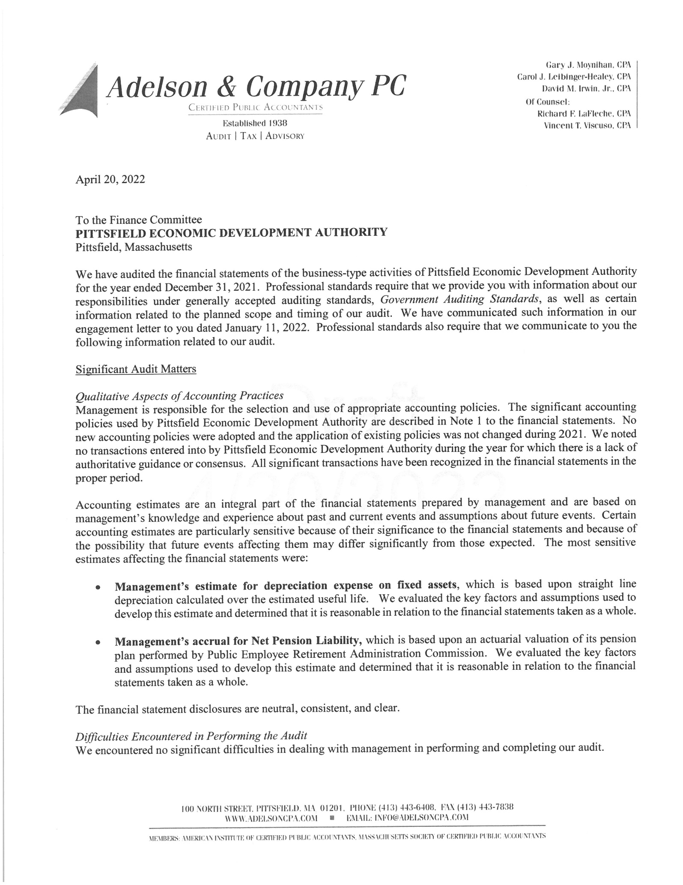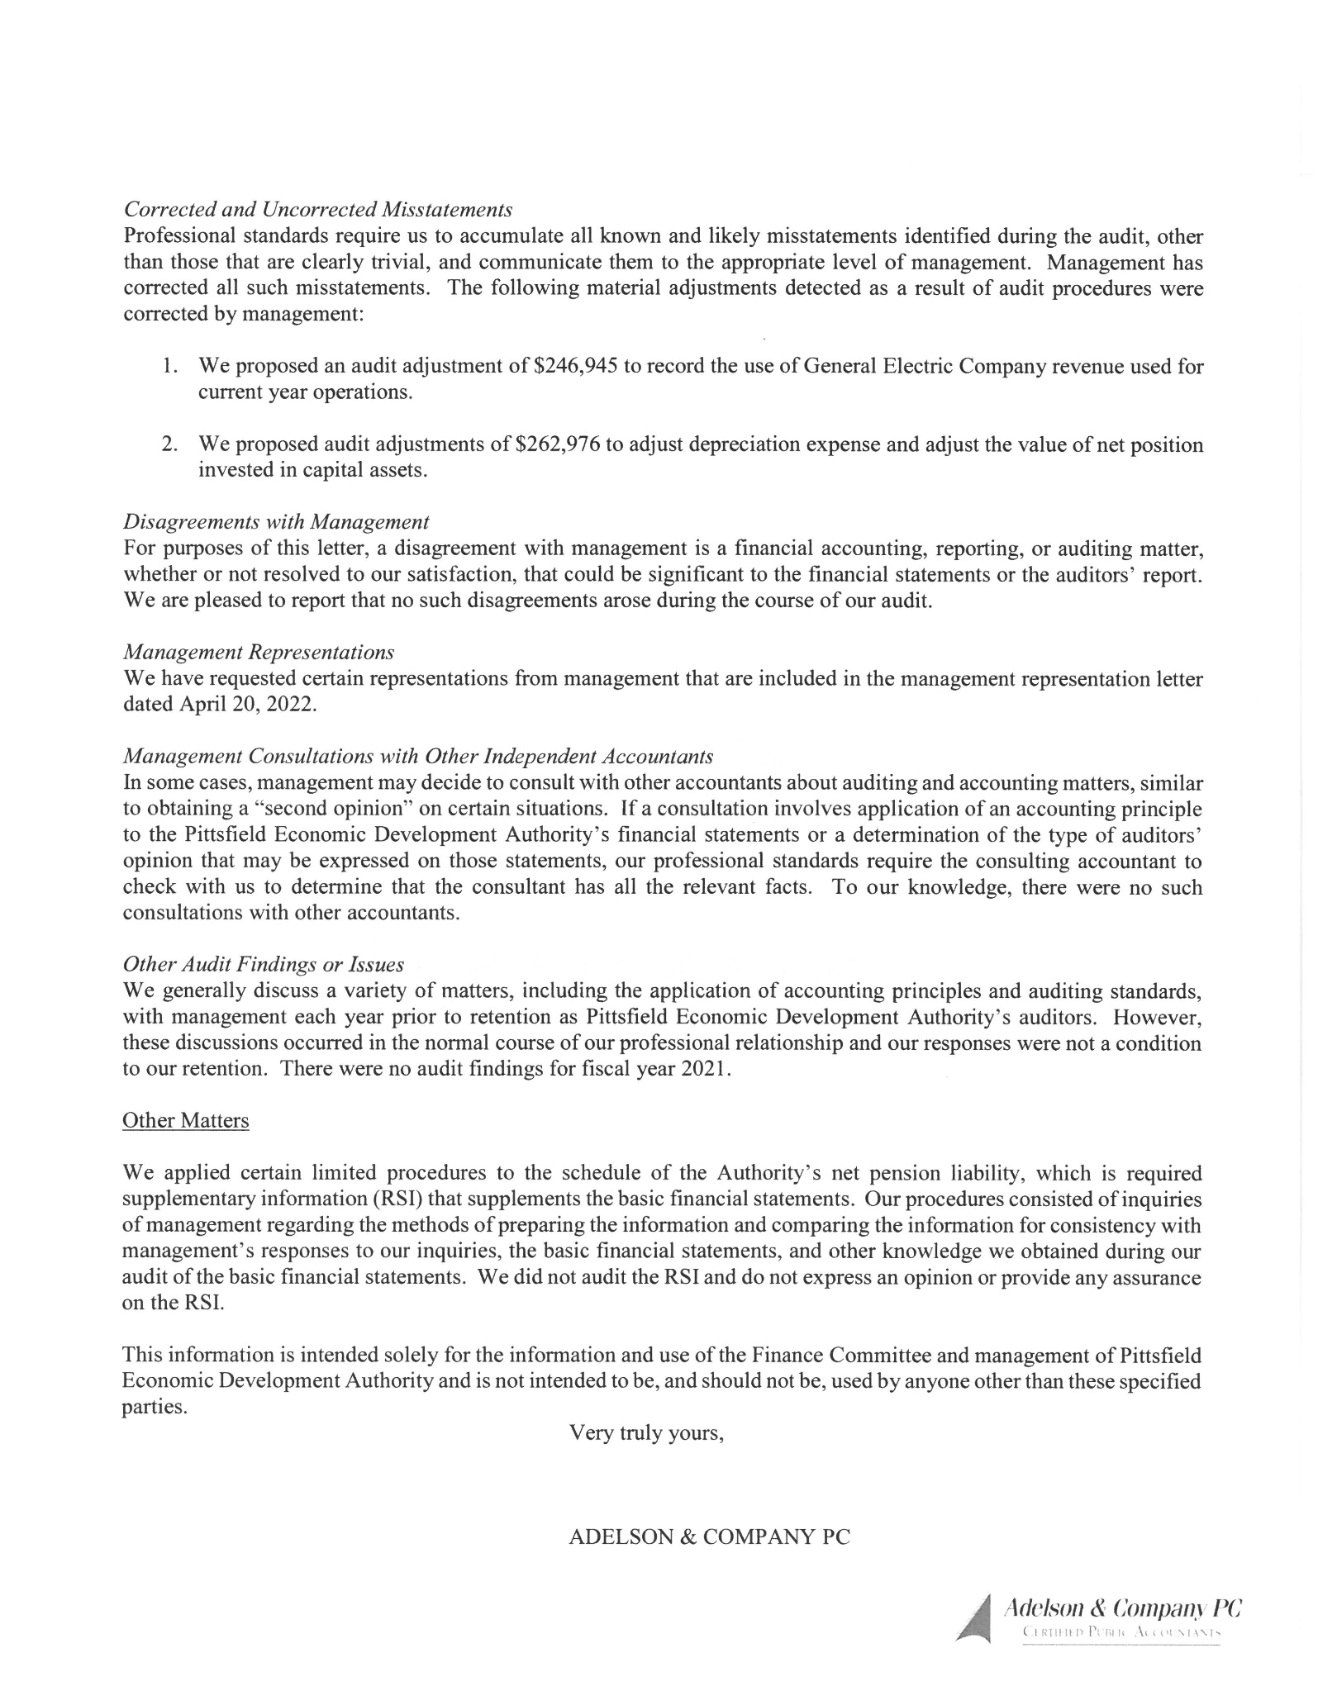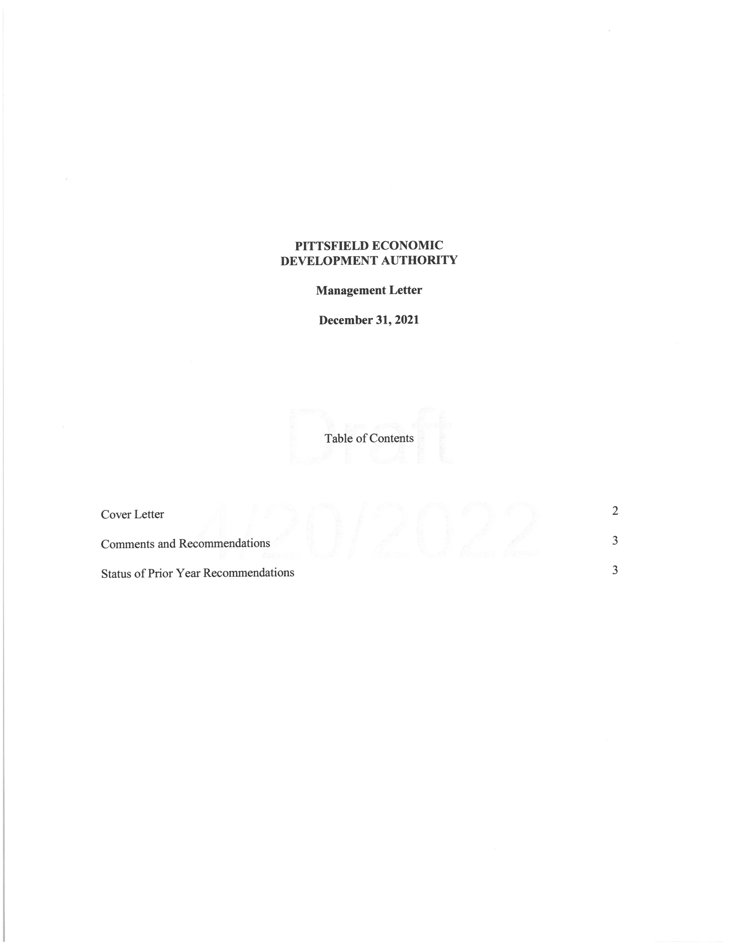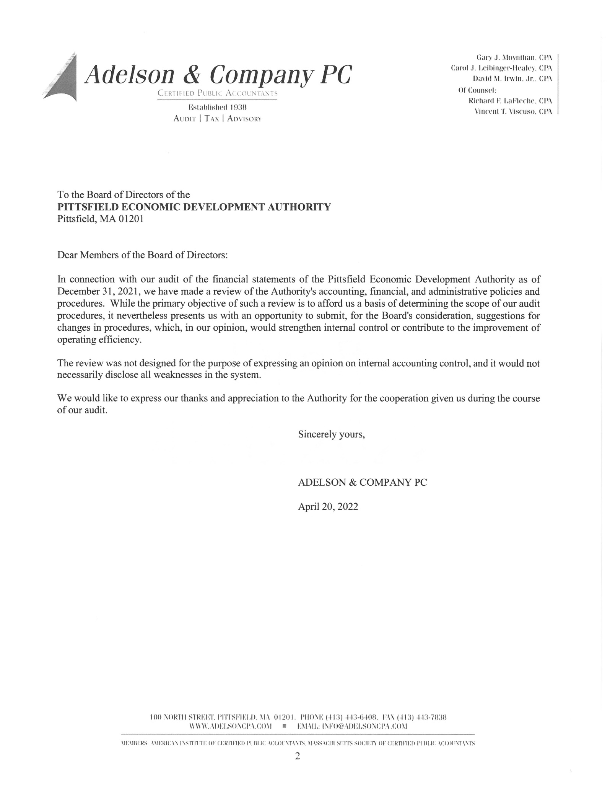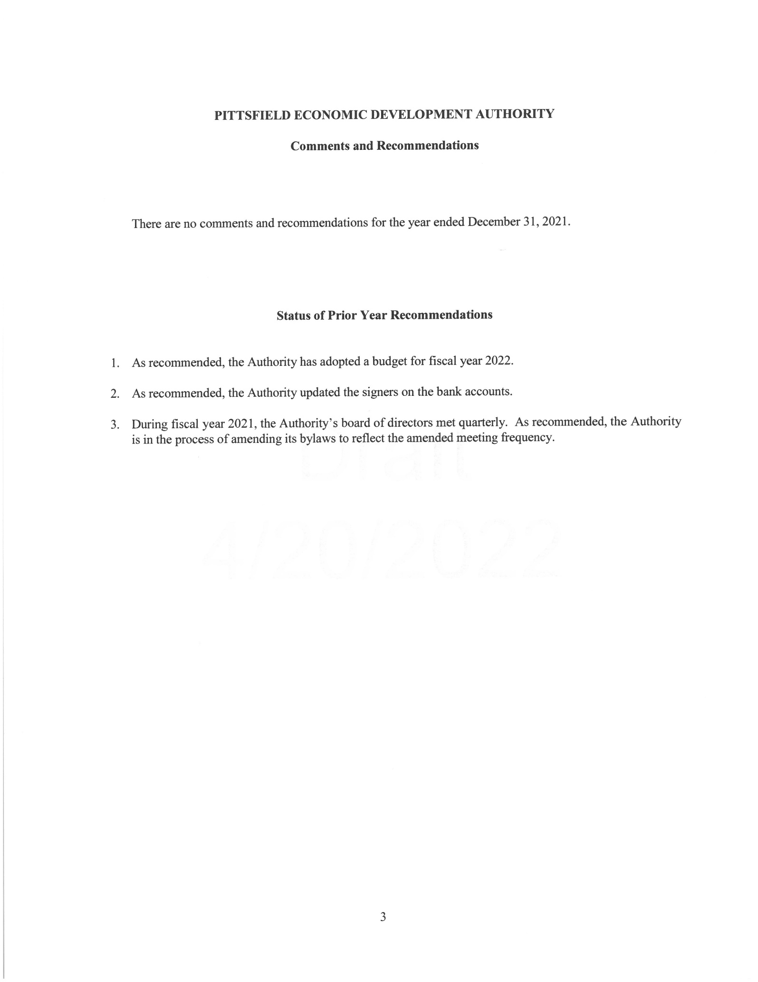

ATTACHMENT A

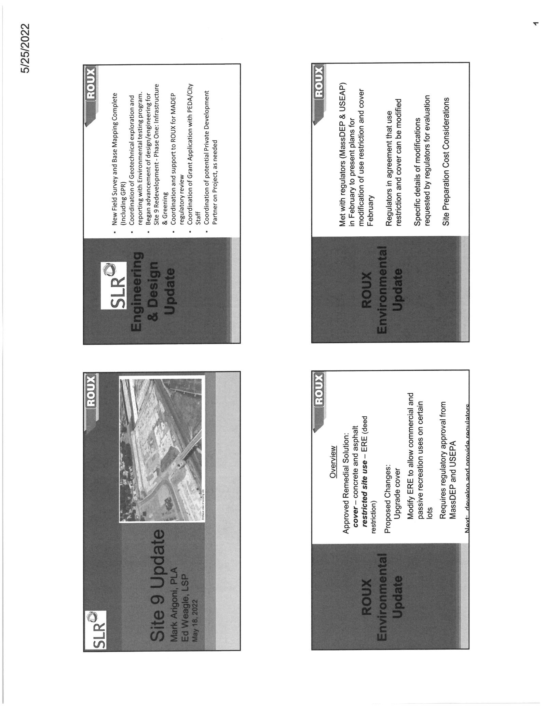

ATTACHMENT B

