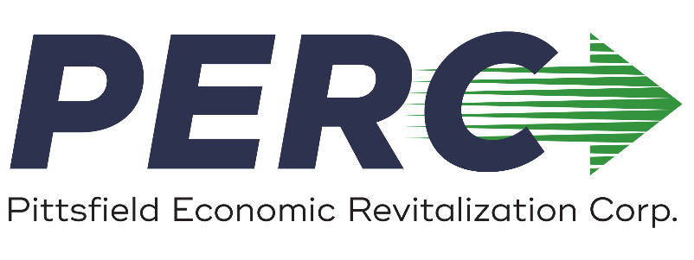
J. Jay Anderson, President Jeffrey Belair, Treasurer
Mark McKenna, Vice President Theodore Kozlowski, Clerk

COMMUNITY DEVELOPMENT
SMALL BUSINESS LOAN PROGRAM

GENERAL

The Pittsfield Economic Revitalization Corporation (PERC) makes loans to qualifying companies making fixed asset investments in Pittsfield that will result in the addition or retention of jobs for low- and moderate-income citizens and families. Loans are made as "companion loans,” in conjunction with Massachusetts or federal programs and/or private financing. The loans are designed to provide financing to businesses unable to obtain such financing in the private market. The source of funding for this program is the federal Community Development Block Grant (CDBG) made available to PERC by the City of Pittsfield.

ELIGIBILITY REQUIREMENTS

- Project must be located in Pittsfield
- Company must meet the following definition of a small business:
(1) Independently owned
(2) Does not have a net worth more than $18 million
(3) Does not have an average income after Federal income taxes for the preceding two years in excess of $6 million.
- The company must document that it is unable to secure financing through conventional sources.
- Applicant must create or retain at least one full-time equivalent, permanent job per $35,000 of CDBG funds used; or applicant is developing a micro-enterprise and is qualified by income to receive assistance:
  - Individuals are eligible if they are Pittsfield residents developing a micro-enterprise (a commercial enterprise that has five or fewer employees, one or more of whom owns the enterprise) and meet low- to moderate-income guidelines.
  - Applicant, if not a micro-enterprise, must guarantee that at least 51% of jobs created or retained will be held by low- or moderate-income residents of Pittsfield as defined by HUD income guidelines.
- All loans are subject to an evaluation as defined by HUD guidelines. The evaluation involves: (1) a verification that costs are reasonable, (2) a confirmation of other sources of funds, (3) a determination that these federal funds are not being substituted for non-federal funds, (4) a determination that the project is financially feasible, (5) a determination that the return on equity is not unreasonably high, (6) a determination that funds can be disbursed on a pro-rata basis, and (7) an assessment and documentation of public benefits. Additional underwriting guidance is taken from the SBA 504 Standard Operating Procedure.
APPLICATION

(1) The staff of the Department of Community Development (DCD) will be responsible for processing of CDBG loan applications.

(2) The applicant will be responsible for all costs associated with the preparation of the application and for any closing fees, including PERC’s legal fees.

(3) The applicant shall pay two points at closing to PERC to cover loan processing and servicing expenses.

APPROVAL

When possible, an applicant will receive approval or disapproval at PERC's next monthly Board meeting when a completed application is submitted at least ten days before a scheduled meeting.

PROGRAM REQUIREMENTS

(1) Loan proceeds are to be used to finance the construction or acquisition of fixed assets and/or working capital needs in conjunction with fixed asset projects.

(2) Loans cannot exceed forty percent (40%) of the applicant's project costs for amounts up to $100,000.

(3) The applicant will be required to invest a minimum of five percent (5%) of project costs from personal resources.

(4) The term of the loan will not exceed the term of loans from other sources.

(5) Loans from other sources shall not have closed prior to approval of the application by PERC.

(6) The interest rate will be determined based on the requirements of the project and the structure of the project financing. The rate will be fixed for the term of the loan.

(7) Any person owning twenty percent (20%) or more of the applicant company, and the Chief Executive Officer of the applicant company, regardless of his/her ownership in the company, must personally guarantee the loan to PERC.

INELIGIBLE PROJECTS

* General promotion of the community as a whole.
* Assistance to professional sports teams.
* Assistance to privately owned recreational facilities that serve a higher-income clientele.
* Acquisition of land for which the specific proposed use has not been identified.
* Businesses that have unresolved non-compliance finding for previous CDBG assistance.

CDBG Small Business Loan Program 2018.docx

